

Lab E5-VHDL Design Project

*EEE20001 Digital Electronics Design*

|  |  |  |  |  |
| --- | --- | --- | --- | --- |
| **1.** | **Student Name:** | **Sze XiJie** | **Student ID:** | **101222928** |
| **2.** | **Student Name:** | **Sarah Lau Li Tin** | **Student ID:** | **101220896** |
| **3.** | **Student Name:** | **Lee Kai Ze** | **Student ID:** | **101222041** |

|  |  |
| --- | --- |
| **Lab Supervisor Name:** | **Dr. Tay Fei Siang** |



May 12, 2021

Swinburne University of Technology Sarawak

Table of Contents

Brief Description 3

Description of Approach 3

Block Diagram of Top-Level Structure 3

State Transition Diagram (STD) 8

Detailed Description of Modules 9

SyncButton Module 9

TrafficLights Module 9

Timer Module 10

MotorController Module 10

TimerReset Module 10

Detailed Description of Simulation 11

SyncButton Module 11

TrafficLights Module 17

Timer Module 21

MotorController Module 25

TimerReset Module 29

Detailed Description on Debugging Process 33

Stepper Motor Will Not Stop Rotating After 5 rotations 33

Traffic Light Flashing Is Not Consistent and Accurate 34

Listing of VHDL Modules 35

ISE Synthesis Report 51

Appendix 59

Figure 1: Block Diagram of Top-Level Structure 4

Figure 2: Block Diagram of TImer Module 4

Figure 3: Block Diagram of TrafficLights Module 5

Figure 4: Block Diagram of SyncButton Module 6

Figure 5: Block Diagram of MotorController Module 7

Figure 6: Block Diagram of TimerReset Module 8

Figure 7: Flowchart of Project 9

Figure 8: State Diagram for MotorController Module 10

Figure 9: State Diagram for TrafficLights Module 10

Figure 10: State Diagram for TimerReset Module 11

Figure 11: State Diagram for SyncButton Module 11

Figure 12: TB_SyncButton TestBench Code 18

Figure 13: SyncButton Module Simulation at 0ns to 1500ns 19

Figure 14: SyncButton Module Simulation at 1500ns to 3000ns 19

Figure 15: TB_TrafficLights TestBench Code 22

Figure 16: TrafficLigths Module Simulation 23

Figure 17: TrafficLights Module Simulation at 200ns to 300ns 23

*Figure 18: TB_Timer TestBench Code* 26

Figure 19: Timer Module Simulation 27

*Figure 20: TB_MotorController TestBench Code* 30

Figure 21: MotorController Module Simulation 31

Figure 22: MotorController Module Simulation at 700ns to 800ns 31

Figure 23: MotorController Module Simulation at 900ns to 1000ns 31

Figure 24: TB_ TimerReset TestBench Code 34

Figure 25: TimerReset Module Simulation 35

Figure 26: MotorController Module Code 41

Figure 27: Timer Module Code 43

Figure 28: TrafficLights Module Code 46

Figure 29: TimerReset Module Code 49

Figure 30: SyncButton Module Code 53

Figure 31: ISE Sysnthesis Report 60

Figure 32: ISE Summary Report 61

Figure 33: TrafficTopLevel.vhd Code 64

Figure 34: TopLevel.ucf Code 65

# Brief Description

## Description of Approach

The aim of the project is to design a traffic light controller which is responsible for controlling the traffic light to have the train as the top priority. It is also required to simulate the gate closing and opening by enabling and rotating the Stepper Motor for 5 rotations to completely close and open and gate. To complete this project, 5 modules are created: SyncButton Module, TrafficLights Module, Timer Module, TimerReset Module and MotorController Module.

SyncButton Module is created to sync all the button inputs. After synchronizing all the inputs, the priorities will also be set to have the train as the top priority, regardless of other button inputs pressed when the train is passing. If the other button inputs are pressed, and the train button is pressed afterwards, the train will pass through while the car and pedestrian will need to wait until the train has passed.

Next, the TrafficLights Module is created to control the traffic lights and also provide an input for the MotorController Module. When train button is pressed, traffic lights will flash red and amber, if car button is pressed, the traffic lights will be green and when the pedestrian button is pressed, the pedestrian light will be on and the traffic lights will be green.

The MotorController Module is created to control the Stepper Motor. By getting the outputs form the TrafficLights Module and the SyncButton Module, the Stepper Motor will enable and rotate in clockwise or counter-clockwise direction depending on the states. If gate is closing, the Stepper Motor will rotate clockwise, while counter-clockwise when the gate is opening.

The Timer Module is created to simulate a timing system for the project. The Timer Module will generate 4Hz pulses for the TrafficLights Module to let the traffic lights flash red and amber, generate motor pulse for the MotorController Module to rotate the Stepper Motor and to generate a counter to keep track of when is the right time to enable or disable the Stepper Motor and to hold the train and pedestrian passing time.

Lastly is the TimerReset Module which is created to reset the Timer Module. This is required to reset the counter for the gate opening and closing to only let it rotate for 5 rotations.

## Block Diagram of Top-Level Structure

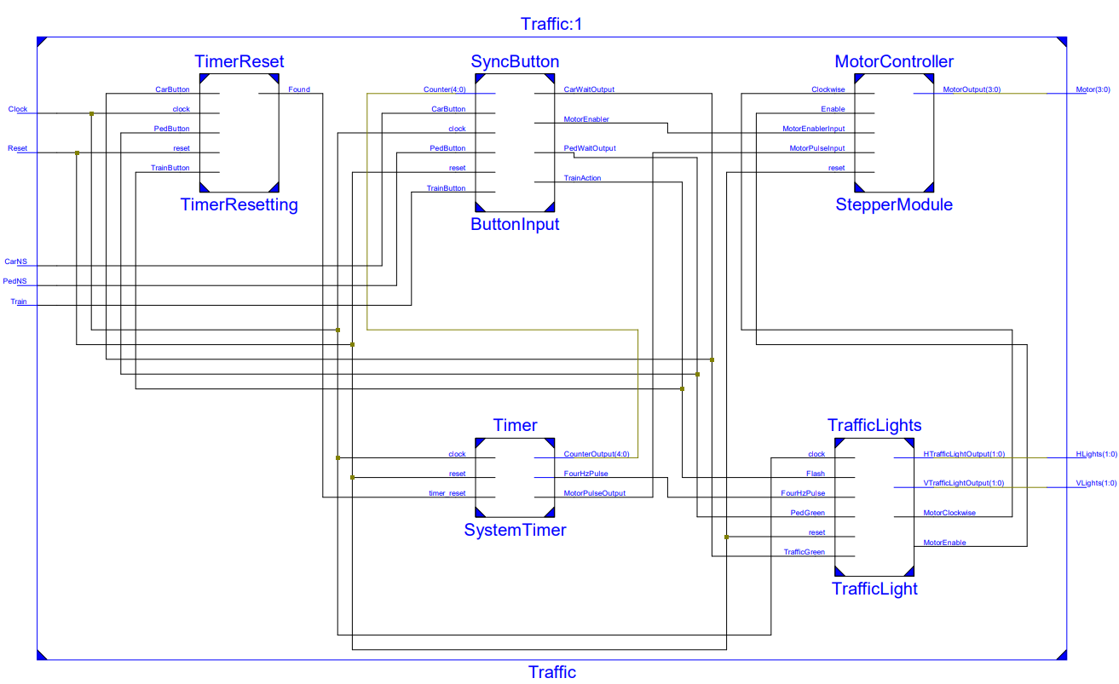

Figure 1: Block Diagram of Top-Level Structure

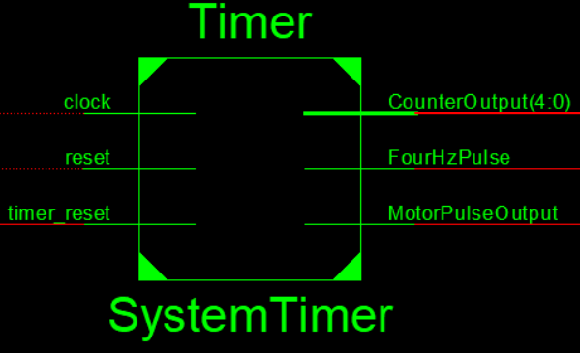

Figure 2: Block Diagram of TImer Module

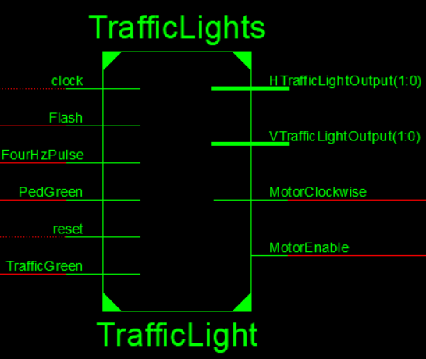

Figure 3: Block Diagram of TrafficLights Module

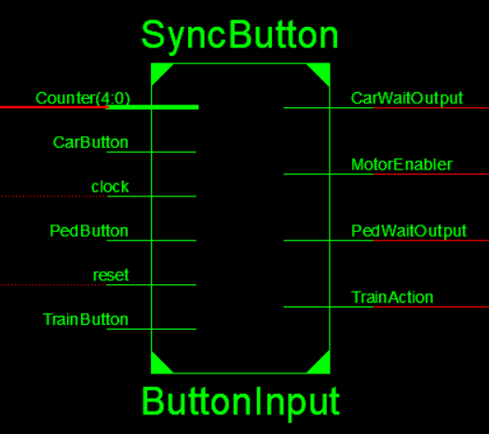

Figure 4: Block Diagram of SyncButton Module

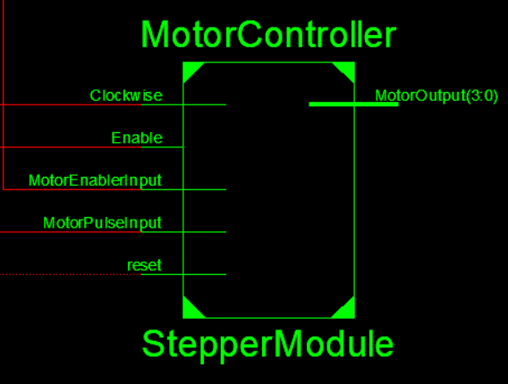

Figure 5: Block Diagram of MotorController Module

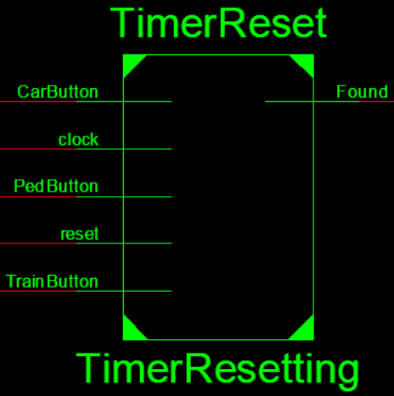

Figure 6: Block Diagram of TimerReset Module

## State Transition Diagram (STD)

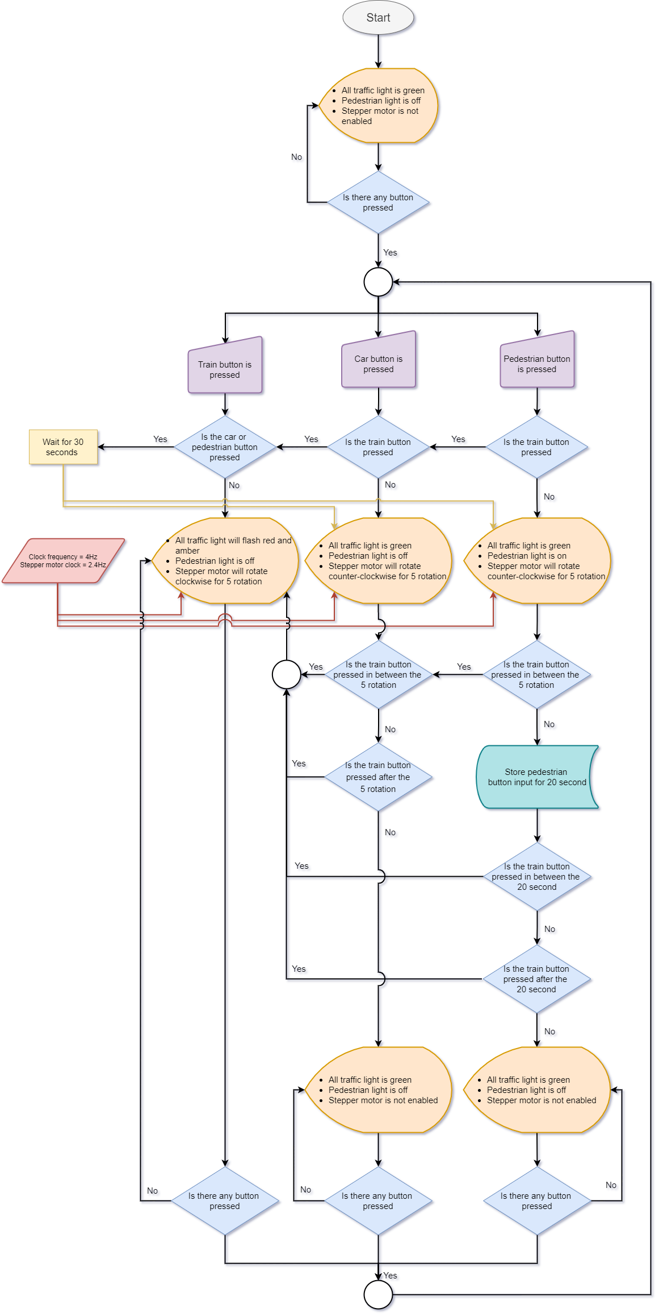

Figure 7: Flowchart of Project

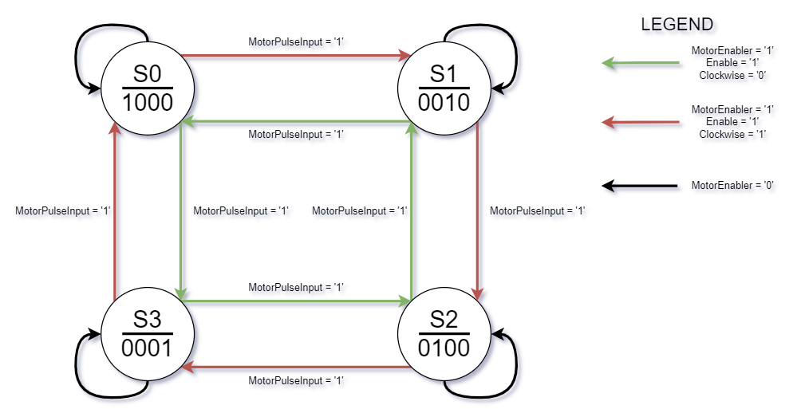

Figure 8: State Diagram for MotorController Module

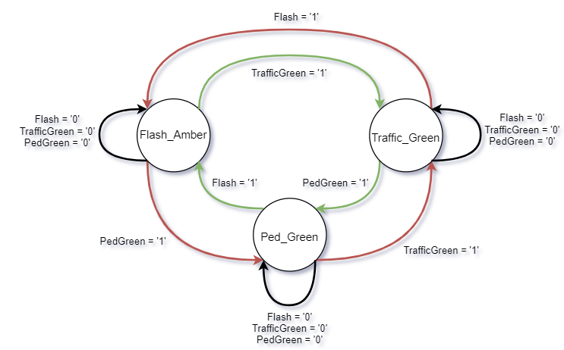

Figure 9: State Diagram for TrafficLights Module

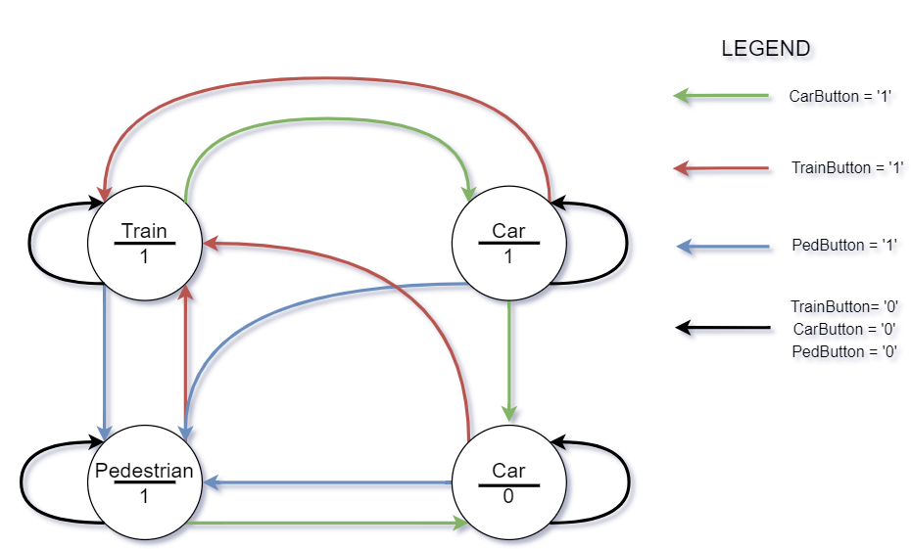

Figure 10: State Diagram for TimerReset Module

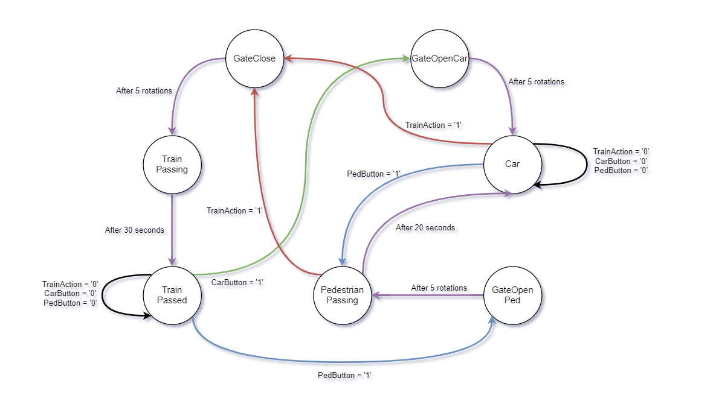

Figure 11: State Diagram for SyncButton Module

## Detailed Description of Modules

For all the modules, reset is connected to the Master Reset which is a button from the Button Module and the clock will be from the Clock Module.

### SyncButton Module

The SyncButton Module is used to sync the button pressed and to identify when to enable the Stepper Motor. In the SyncButton Module, a Moore Machine is used to give an accurate output. 7 states will be used in the Moore Machine, which is GateClose, GateOpenCar, GateOpenPed, TrainPassing, TrainPassed, Car, PedestrianPassing states. Initailly, the state will be Car when the master reset is pressed. Then when it detects the train button is pressed, it will move to GateClose state to close the gate. After it has closed the gate, it will move to TrainPassing state to simulate the train is passing. After it has finished, it will move to TrainPassed state to simulate that the train has passed. In GateClose and TrainPassing states, when the car or pedestrian button is pressed, it will be ignored as the train takes priority. It will only receive the button inputs when it is in TrainPassed state. So, during that state, when car button is pressed, it will move to GateOpenCar to open the gate, then after gate is fully opened, it will move to Car state. Now, when a pedestrian button is pressed, the gate will not open again as it is already opened, and it will directly move to PedestrianPassing state and hold the input for 20 seconds to let the pedestrian cross the road. If a train button is pressed in between the 20 seconds, the gate will start to close again. Similarly, instead of car button pressed when the state is at TrainPassed state, if a pedestrian button is pressed, the state will move to GateOpenPed and then move to PedestrianPassing state. During GateClose, GateOpenCar, GateOpenPed, MotorEnablerOutput will be ‘1’ to enable the Stepper Motor and at TrainPassing, TrainPassed, Car, PedestrianPassing states, the MotorEnablerOutput will be ‘0’, to disable the Stepper Motor as it has finished rotating 5 times. TrainAction, CarWaitOutput and PedWaitOutput will output accordingly when the corresponding button is pressed. Refer to Figure 30: SyncButton Module Code for full view of code.

### TrafficLights Module

The TrafficLights Module is used to control the traffic lights and the pedestrian lights. The TrafficLights Module also uses Moore Machine to determine the output for the traffic lights and Stepper Motor. Initially, the state will be set at Traffic_Green state. When the train button is pressed, the state will move to Flash_Amber state. In this state, the traffic lights will flash red and amber according to the 4Hz pulse and the Stepper Motor will rotate in a clockwise direction to simulate the closing of the gate. If the car button is pressed, the state will move back to Traffic_Green state. The Stepper Motor will rotate counter-clockwise to simulate gate opening and the traffic lights will be green. Similarly, in Flash_Amber state, if the pedestrian button is pressed, the state will move to PedGreen state where the Stepper Motor will also rotate counter-clockwise to simulate opening of gate and the traffic lights will be green and pedestrian light will be on. The same goes to when the pedestrian button is pressed in Traffic_Green state. During PedGreen state, if the train button is pressed, the state will move to Flash_Amber state. The reason why there is no code to check if the pedestrian or train has finished its action based on the timer is because this action is done in SyncButton Module. Therefore, the TrafficLights Module only needs to output for the traffic light, pedestrian lights, and the motor rotation. Refer to Figure 28: TrafficLights Module Code for full view of code.

### Timer Module

For Timer Module, there will be reset, timer_reset and rising clock edge. The reset will be for the master reset which is a button input from the hardware to reset everything, the timer_reset will be to reset the timer whenever a state change from train to car/pedestrian or car/pedestrian to train occurs. And if none of the above happens, timer will increment based on the rising clock edge. So, whenever the counter reaches “1111101000” which is 1 seconds, the timekeeper will increment by 1. Then, when the counter reaches the same binary as the MotorCount, then MotorPulseOutput will output 1 and MotorCount will increment by “0001010011” which is 83 pulses to determine the next MotorPulseOutput or else MotorPulseOutput will output 0. Refer to Figure 27: Timer Module Code for full view of code.

### MotorController Module

For the MotorController Module, it is simple. The module consists of a moore machine which will change states based on the MotorEnablerInput, Enable and Clockwise inputs. Initially, the state will be reset to S0 which will output “1000” for the Stepper Motor and following the rising clock edge of the MotorPulseInput, it will change states. When MotorEnablerInput is ‘0’, the Stepper Motor will not be enabled for all states, thus it will hold the current states until MotorEnablerInput is ‘1’. MotorEnablerInput essentially lets the Stepper Motor to rotate 5 rotations then disabling it to simulate the gate finished closing or opening. When MotorEnablerInput is still ‘1’, if Enable is ‘0’, the Stepper Motor still will not be enabled until is it ‘1’, when it is ‘1’, depending on the Clockwise input, it will either rotate clockwise or counter-clockwise. When Clockwise is ‘1’, the Stepper Motor will rotate clockwise, and the state change will be as follows: S0 to S1 to S2 to S3. If Clockwise is ‘0’, the Stepper Motor will rotate counter-clockwise and the state change will be as follows: S0 to S3 to S2 to S1. Refer to Figure 26: MotorController Module Code for full view of code.

### TimerReset Module

For the TimerReset Module, a Moore Machine will be used to determine when the timer reset will happen. Initially, the state will be at Car. When the state changes from Car to Train due to Train Button is pressed, Found will output ‘1’. This means that the timer will be reset. The same happens when Train state changes to Car or Pedestrian state and Pedestrian state changes to Train state. But when Car state changes to Pedestrian state, Found will output ‘0’ which means the timer will not be reset. However, when Pedestrian state changes to Car state, Found will output ‘1’ to reset the timer. Refer to Figure 29: TimerReset Module Code for full view of code.

## Detailed Description of Simulation

### SyncButton Module

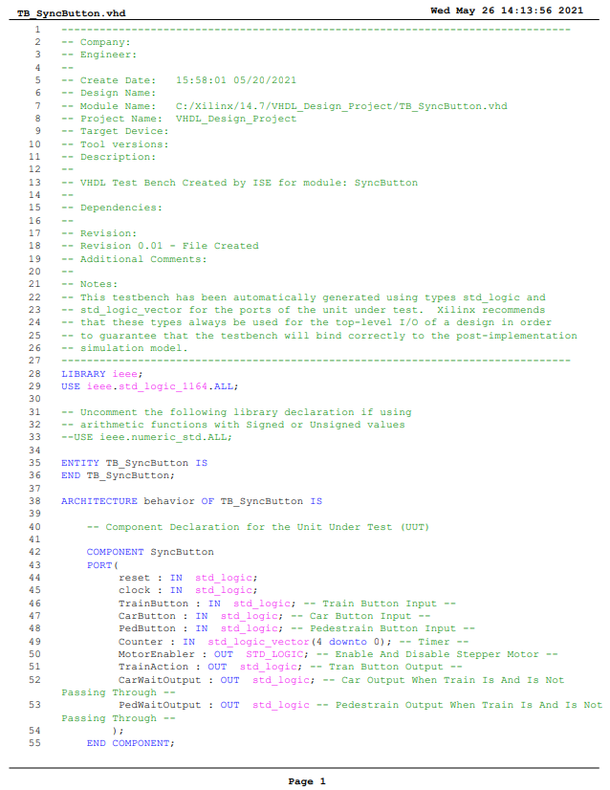

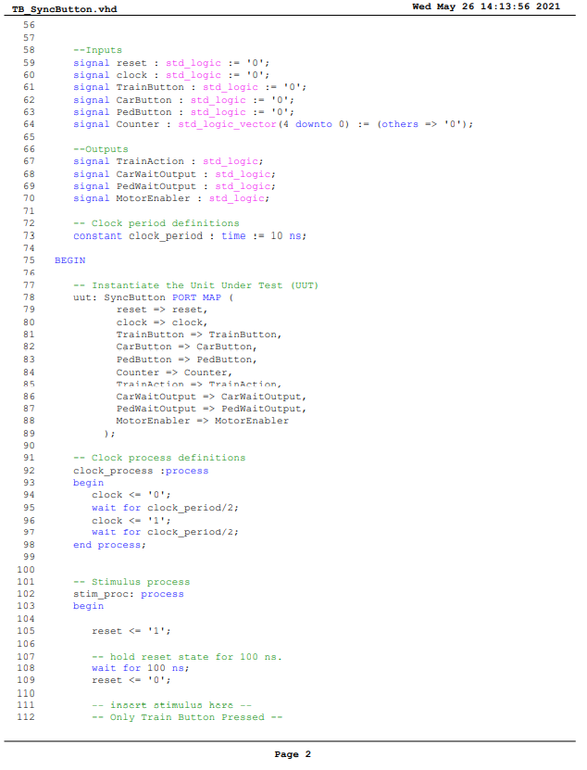

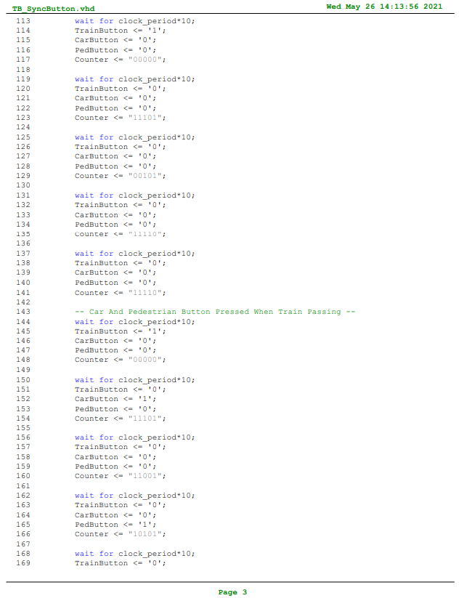

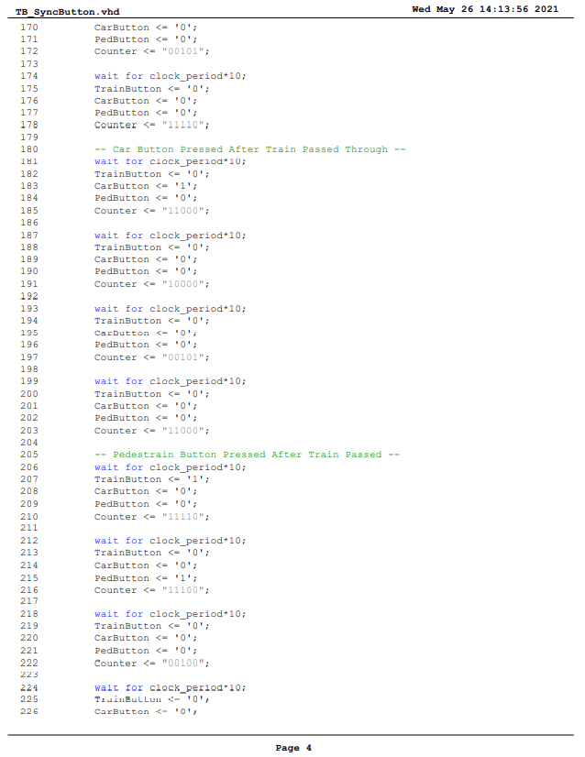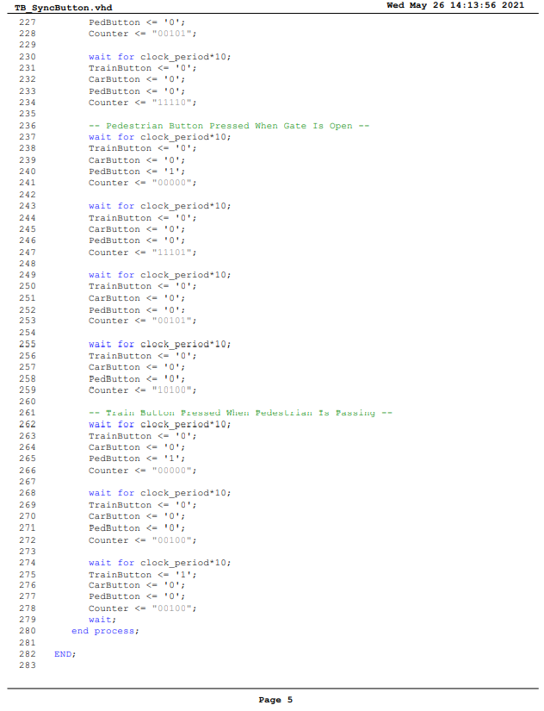

Figure 12: TB_SyncButton TestBench Code

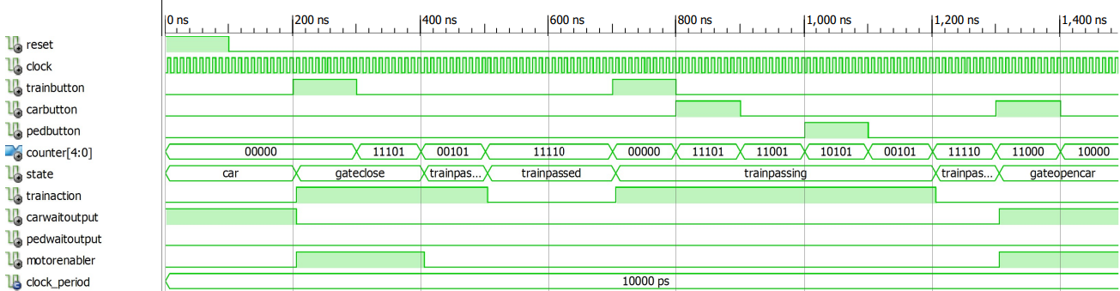

Figure 13: SyncButton Module Simulation at 0ns to 1500ns

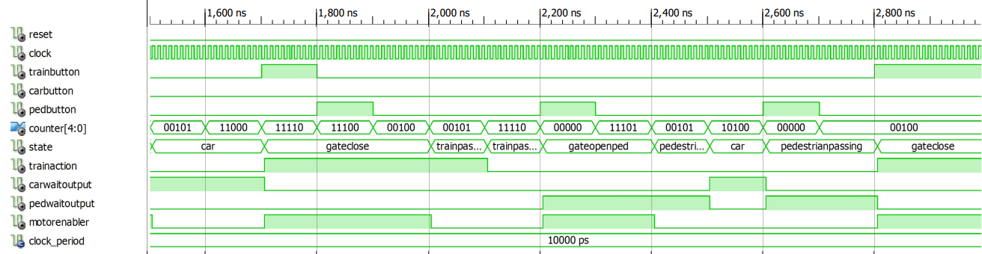

Figure 14: SyncButton Module Simulation at 1500ns to 3000ns

As shown in Figure 13: SyncButton Module Simulation at 0ns to 1500ns and Figure 14: SyncButton Module Simulation at 1500ns to 3000ns, the state will initially be at Car state. When the train button is pressed, it will go to GateClose state until Counter reaches “00101” then it will move to TrainPassing state. Then, when Counter reaches “11110”, it will move to TrainPassed state. Note that during TrainPassing state, it will prioritize the train input even if the car and pedestrian button is pressed. When at TrainPassed state, if car button is pressed, it will move to GateOpenCar state. When Counter reaches “00101”, it will move to Car state. If train button is pressed again, it will move to GateClose state and repeat the steps. Similarly, when the pedestrian button is pressed at TrainPassed state, the state will move to GateOpenPed state until “00101” where it will move to PedestrianPassing state until Counter reaches “10100” where it will move to Car state after “10100”. But when the train button is pressed when the pedestrian is still passing in the PedestrianPassing state, the train will take first priority and the gate will state to close at GateClose state. Note that when at GateClose, GateOpenCar and GateOpenPed state, the MotorEnabler is ‘1’, this is to enable the Stepper Motor to rotate. And also, during each specific state, different output will be ‘1’. For instance, at GateClose, TrainPassing and TrainPassed state, the TrainAction is ‘1’. At GateOpenCar and Car state, the CarWaitOutput is ‘1’ and lastly at GateOpenPed and PedestrianPassing state, the PedWaitOutput is ‘1’.

### TrafficLights Module

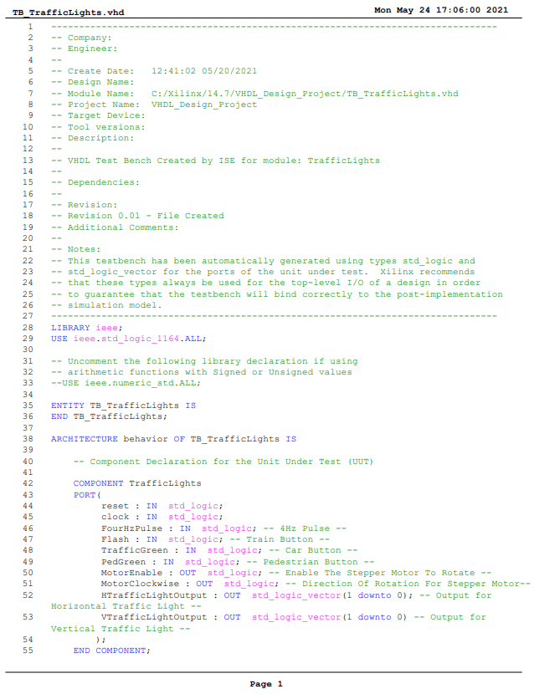

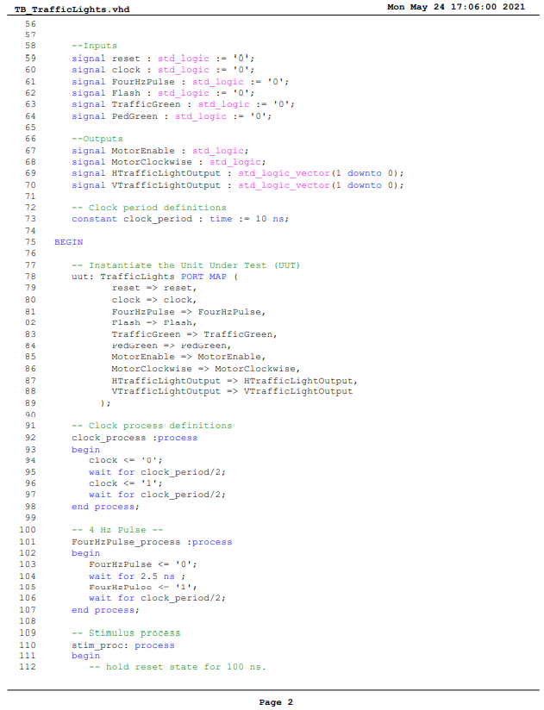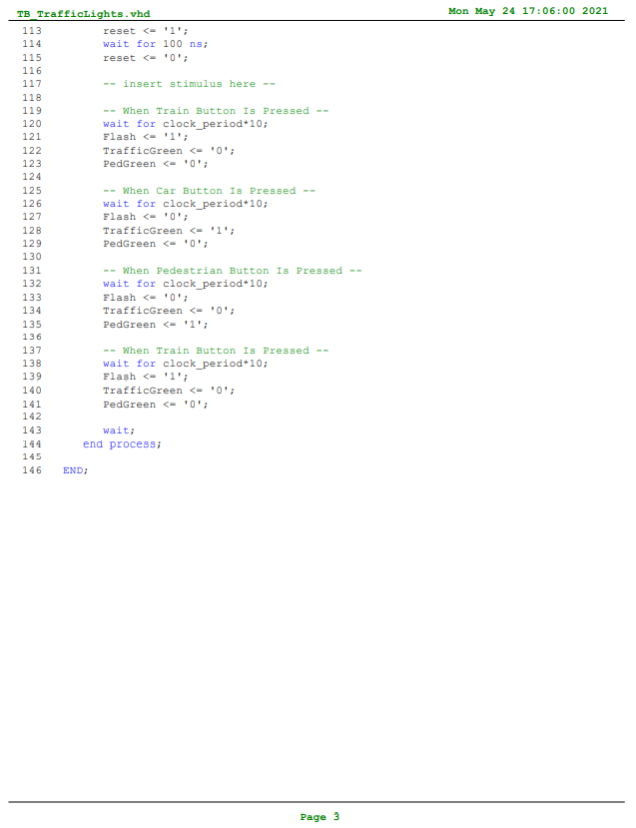

Figure 15: TB_TrafficLights TestBench Code

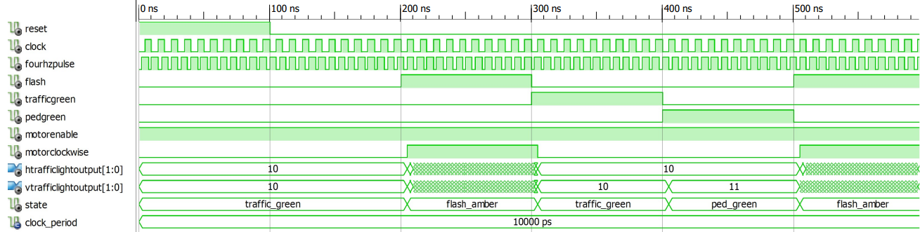

Figure 16: TrafficLigths Module Simulation

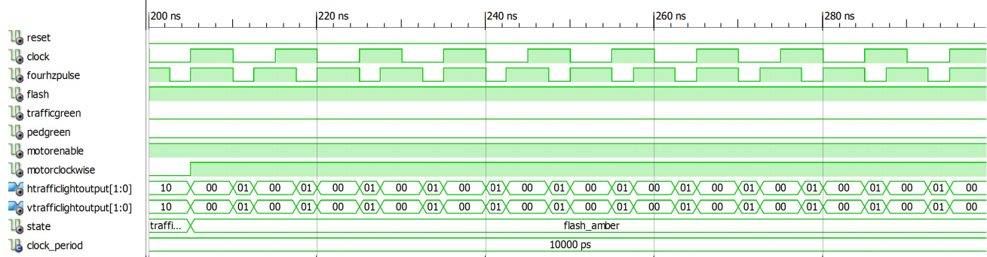

Figure 17: TrafficLights Module Simulation at 200ns to 300ns

As shown in Figure 17: TrafficLights Module Simulation at 200ns to 300ns, the initial state will be Traffic_Green state. When Flash is ‘1’, meaning train button is pressed, the state will move to Flash_Amber state where the output for both traffic lights will be “00” and “01”. The MotorClockwise will also output ‘1’ to make the Stepper Motor rotate in a clockwise direction. When the car button is pressed, the state will move to Traffic_Green state where both traffic lights will output “10”. Then, when the pedestrian button is pressed, the state will move to Ped_Green state where both traffic lights will turn green, and the pedestrian light will be on indicated by the “11” output from VTrafficLightOutput. In both Traffic_Green and Ped_Green state, the MotorClockwise output will be ‘0’ to make the Stepper Motor rotate in a counter-clockwise direction. In all the states, the MotorEnable output will be ‘1’ to enable to Stepper Motor. Refer to FIG XX for a full view of the testbench code.

### Timer Module

*Figure 18: TB_Timer TestBench Code*

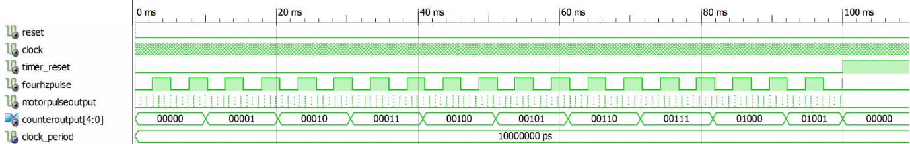

Figure 19: Timer Module Simulation

As shown in Figure 19: Timer Module Simulation, when the timer_reset is ‘1’, the CounterOutput will reset back to “0000” and the MotorPulseOutput and FourHzPulse will be ‘0’. The CounterOutput will continue to count when the timer_reset is ‘0’ following the positive clock edge and the FourHzPulse and MotorPulseOutput will also continue to pulse at set durations again. Refer to FID XX for full view of testbench code.

### MotorController Module

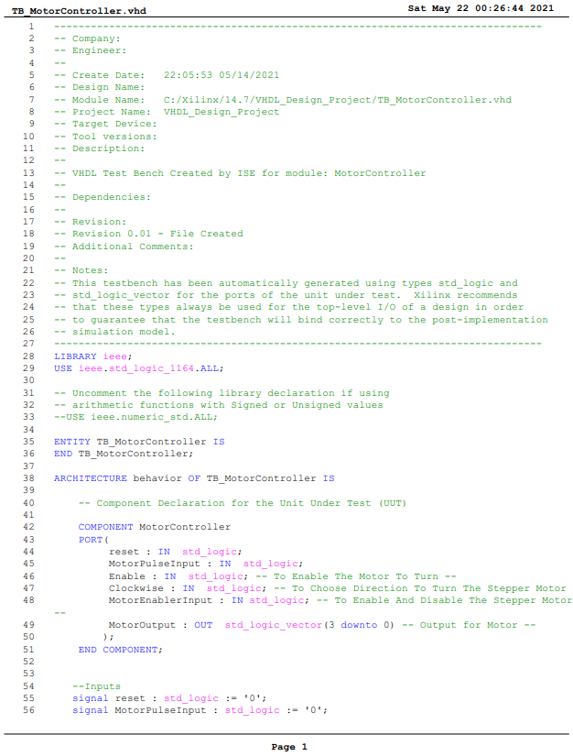

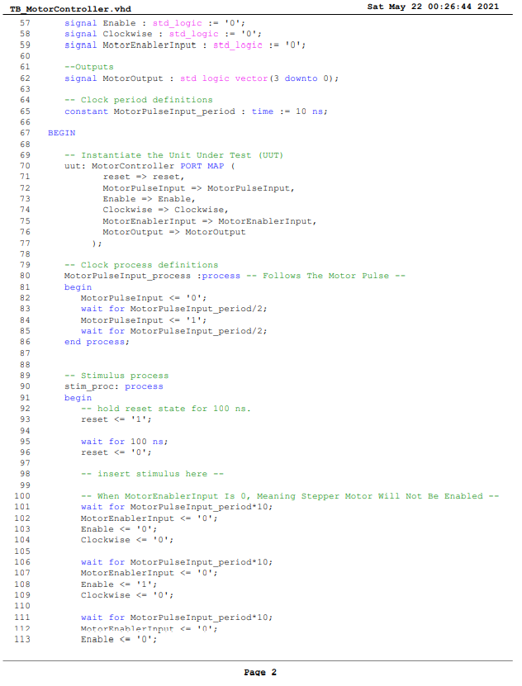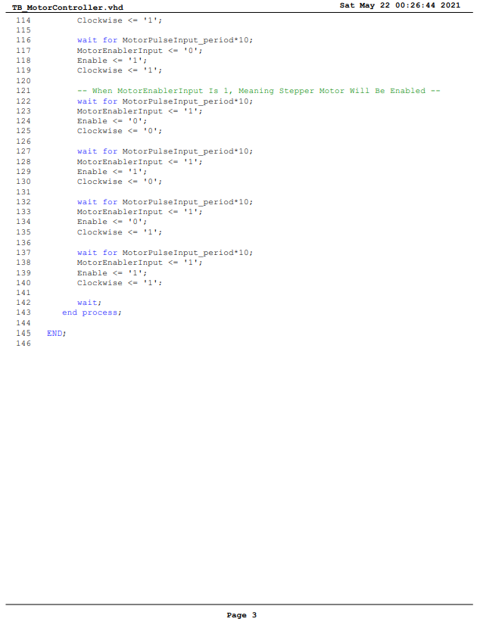

*Figure 20: TB_MotorController TestBench Code*

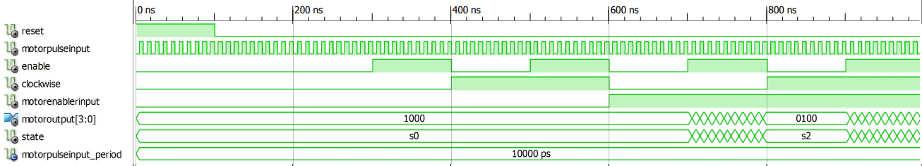

Figure 21: MotorController Module Simulation

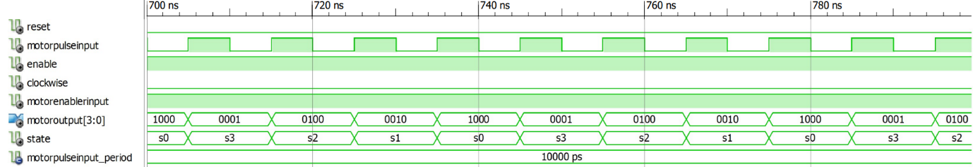

Figure 22: MotorController Module Simulation at 700ns to 800ns

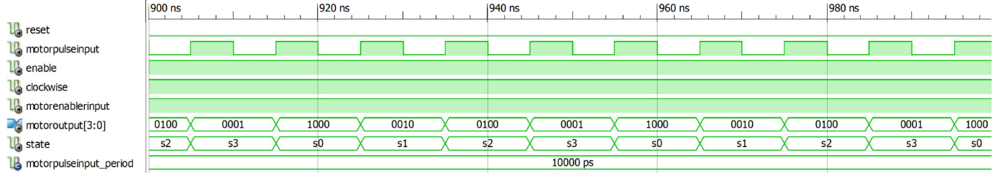

Figure 23: MotorController Module Simulation at 900ns to 1000ns

As shown in Figure 21: MotorController Module Simulation, the state will only change when both MotorEnablerInput and Enable are ‘1’ and it will only changes when it detects MotorPulseInput is ‘1’. From Figure 22: MotorController Module Simulation at 700ns to 800ns, observing the state it can be seen that the state is decrementing or moving backwards. This means that the Stepper Motor will rotate in a counter-clockwise direction thus the clockwise input is ‘0’. From Figure 23: MotorController Module Simulation at 900ns to 1000ns, observing the state, the state is incrementing or moving forward. This means that the Stepper Motor will rotate in a clockwise direction thus the clockwise input is ‘1’. One thing to note is that the state will only change when the MotorPulseInput is ‘1’.

### TimerReset Module

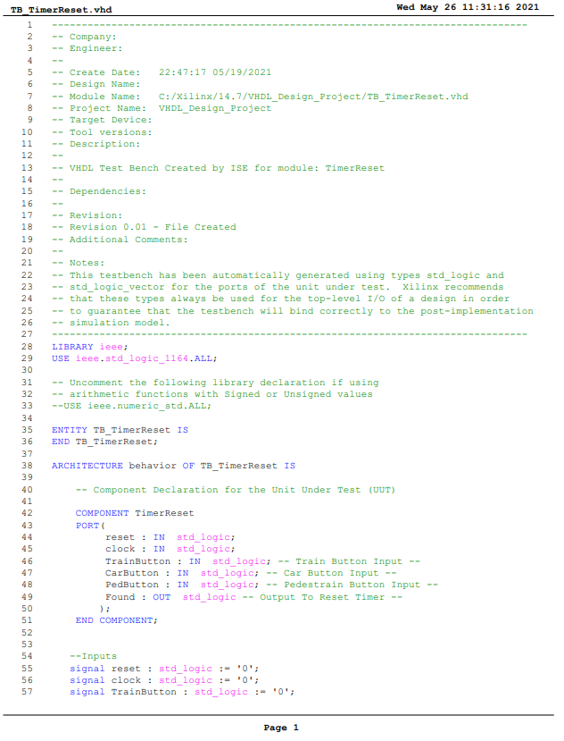

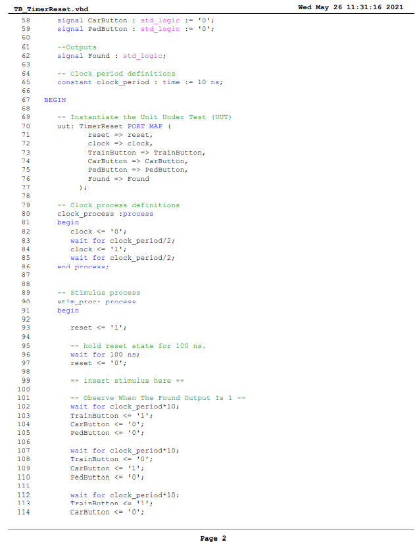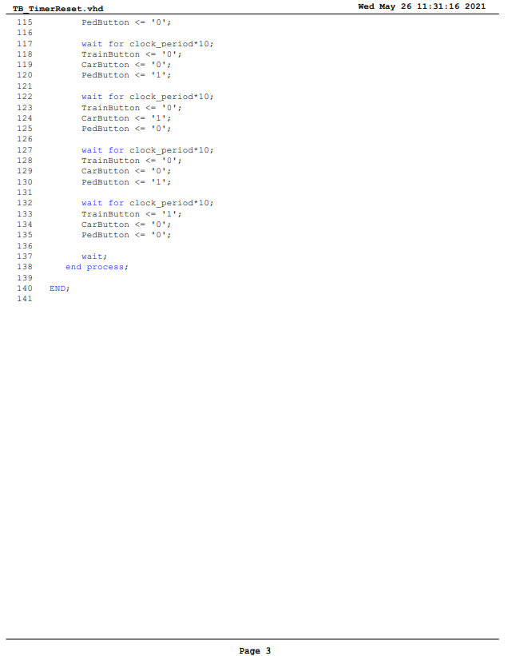

Figure 24: TB_ TimerReset TestBench Code

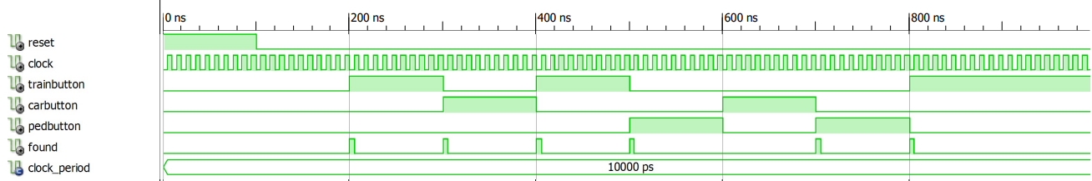

Figure 25: TimerReset Module Simulation

As shown in Figure 25: TimerReset Module Simulation, when Car state is changed to Train state or vice versa, the Found output will be ‘1’ to reset the timer. The same happens when Train state moved to Pedestrian state and vice versa. But when Pedestrian state moved to Car state or vice versa, the Found output will be ‘0’ because the timer does not need to be reset. But when Car state moved to Pedestrian state, the Found output will be ‘1’.

## Detailed Description on Debugging Process

### Stepper Motor Will Not Stop Rotating After 5 rotations

It was found that the stepper motor will continue to rotate even after 5 rotations due to our code not disabling the stepper motor after it has rotated 5 times. To fix this, we have added 3 more states in the SyncButton Module for when the gate is closing, gate opening when pedestrian button is pressed and gate opening when car button is pressed after the train has passed.

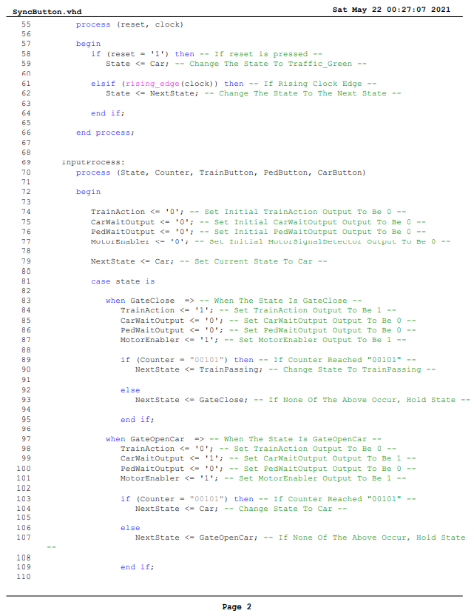

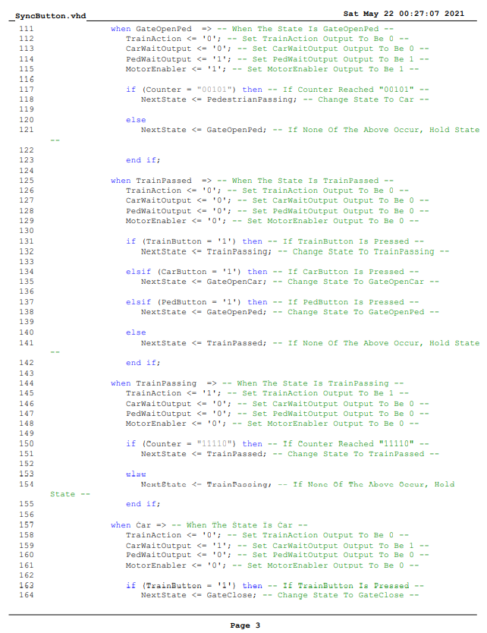

The MotorEnabler output is to control when to enable the stepper motor during these states, the MotorEnabler output will be 0 when it has exited these three states meaning that the gate has completely closed or opened when the Counter has reached “00101” or 5 seconds. Refer to Figure 26: MotorController Module Code for the full view of the code.

### Traffic Light Flashing Is Not Consistent and Accurate

It was found that the traffic light would flash red and amber with glitches. It will flash with an inconsistent timing due to the states that are created in our previous coding in TrafficLights Module. Previously, we have implemented two states for the traffic lights to flash, which is Flash_Amber state and Flash_Red states. The inconsistent timing only occurred when we have downloaded the code onto the CMOD chips and observed it on the hardware, surprisingly it was glitch free during the simulation. Because of the two states switching back and forth when a 4Hz pulse is detected, it caused the inconsistency to occur. To fix this, we removed one of the states, as for our current code, we have removed the Flash_Red state. Refer to Figure 28: TrafficLights Module Code for the full view of the code. After removing one of the states and making the output change from red to amber when it detects a 4Hz pulse, it has solved the inconsistency.

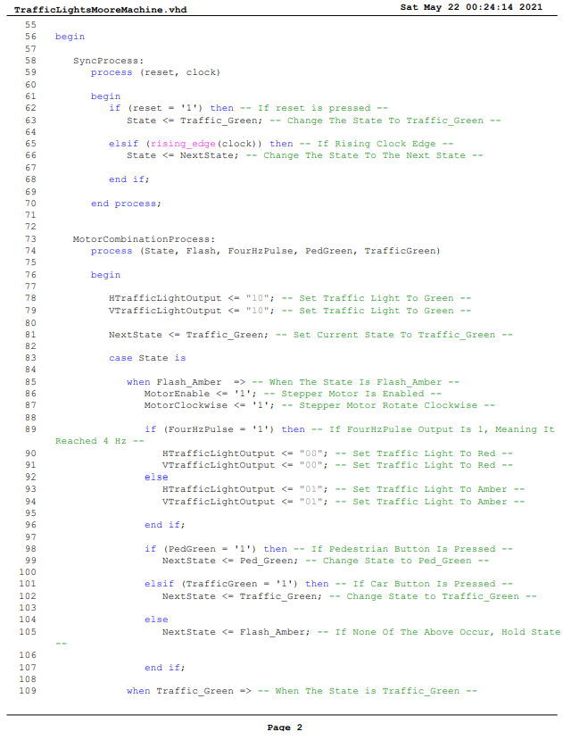

# Listing of VHDL Modules

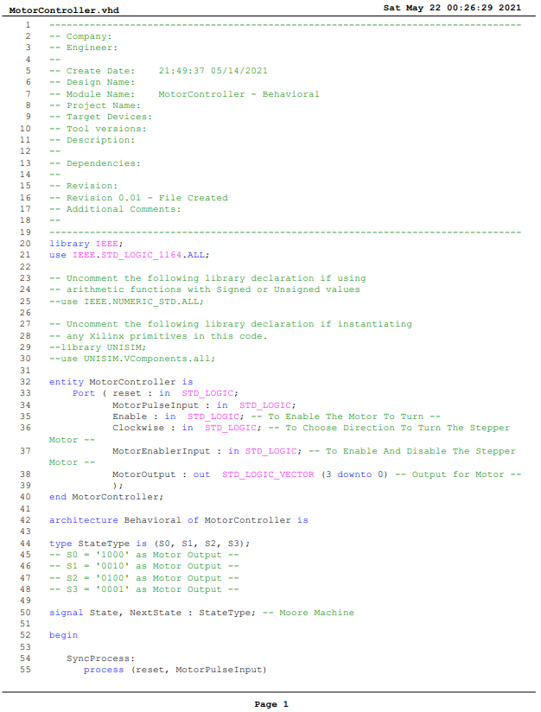

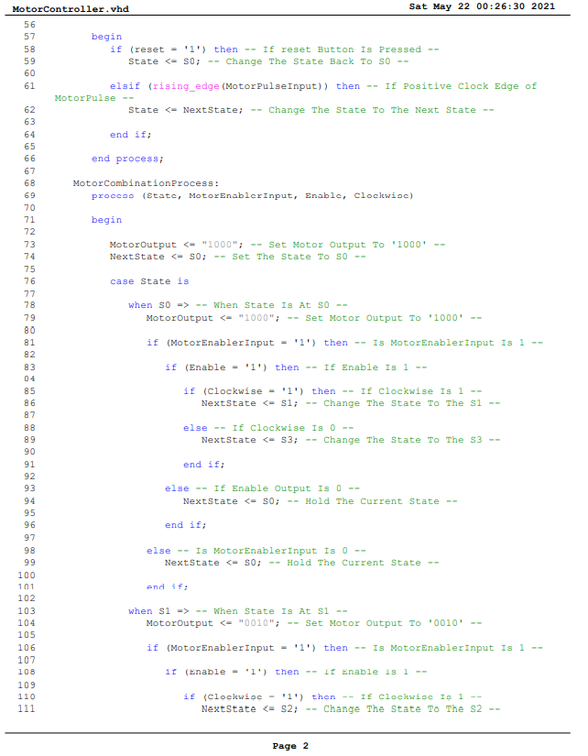

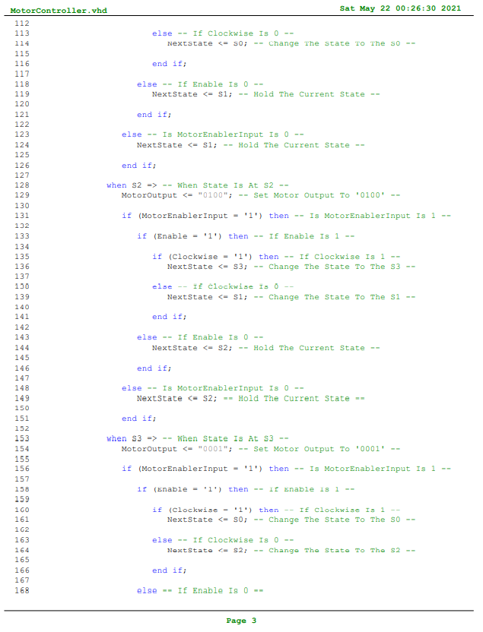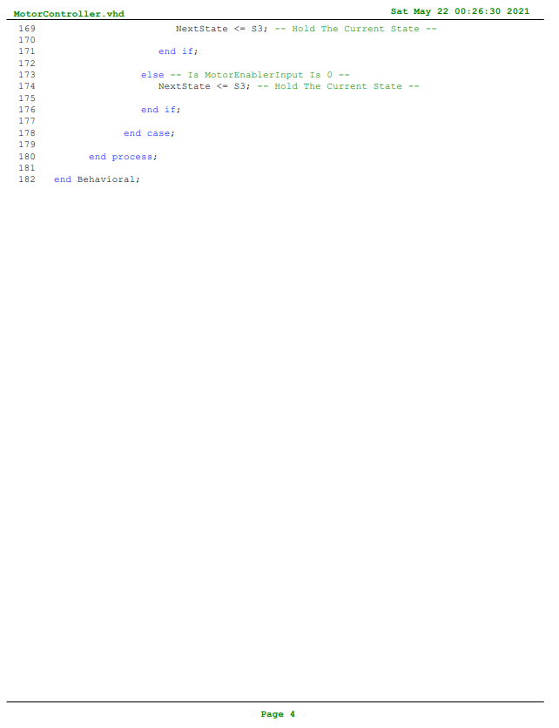

Figure 26: MotorController Module Code

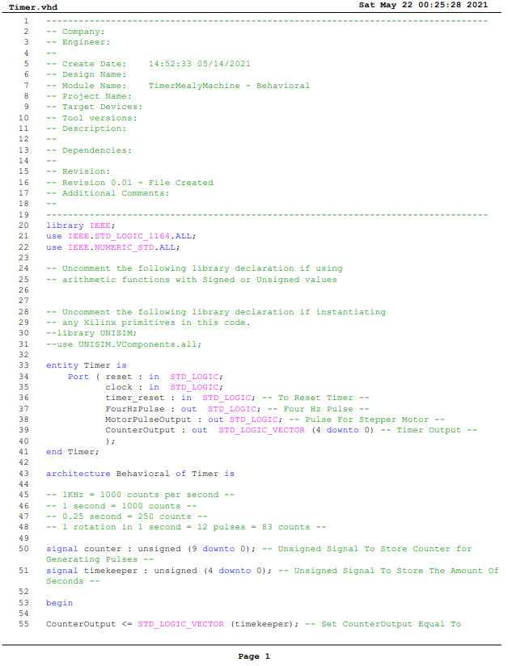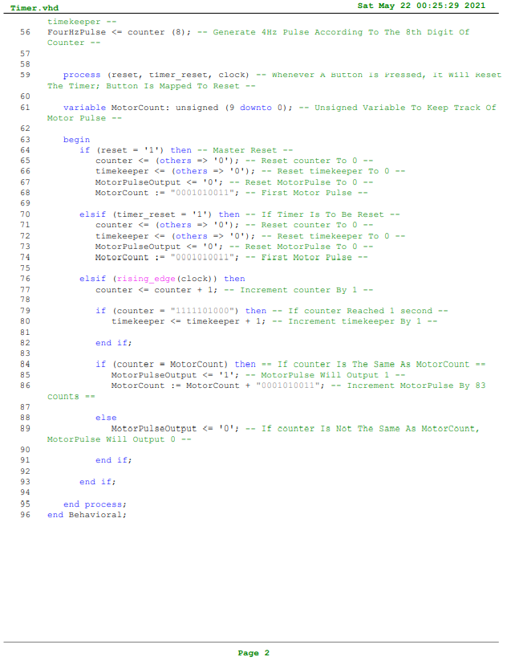

Figure 27: Timer Module Code

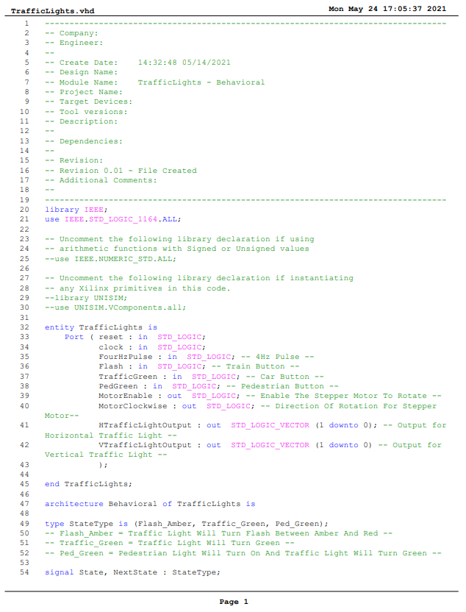

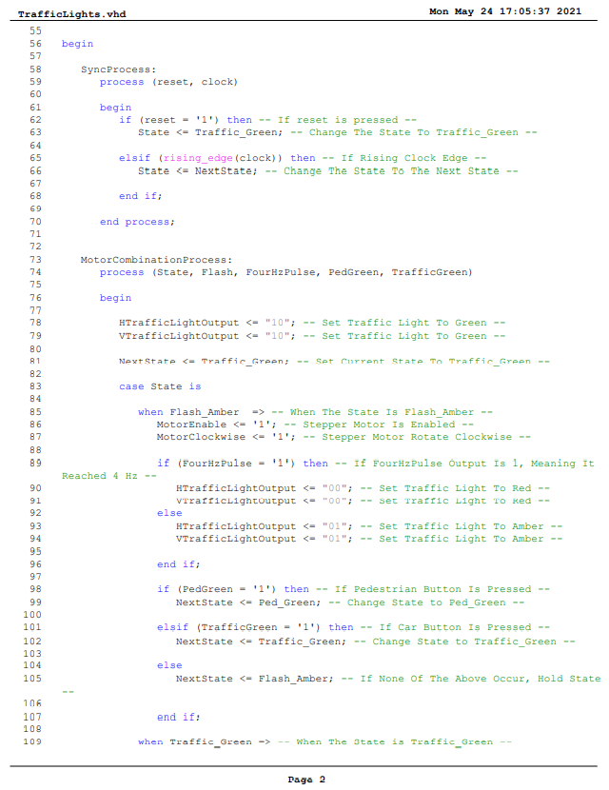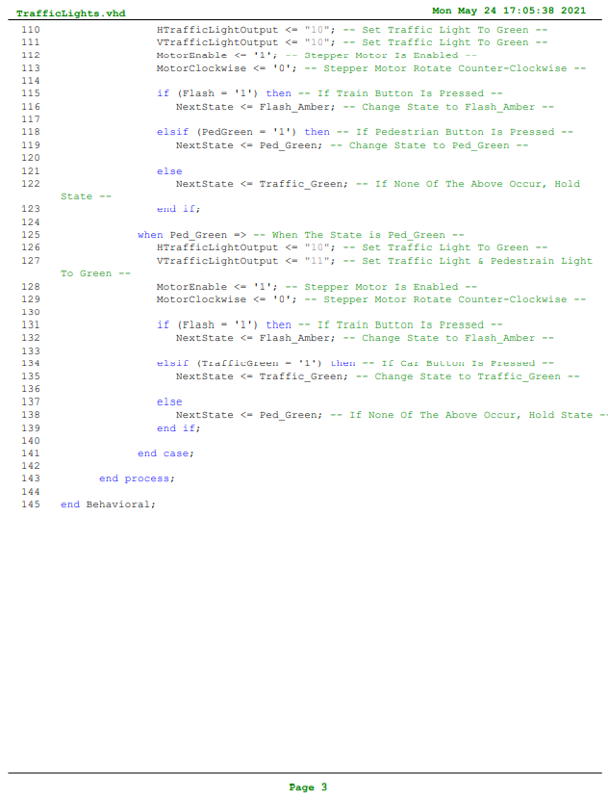

Figure 28: TrafficLights Module Code

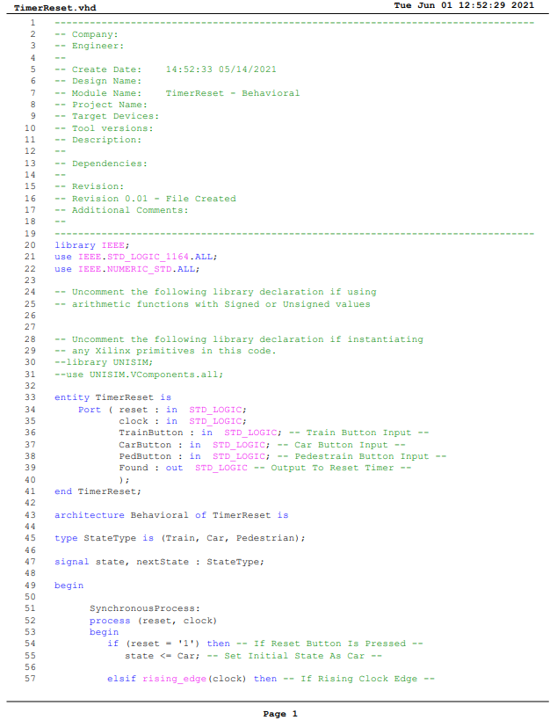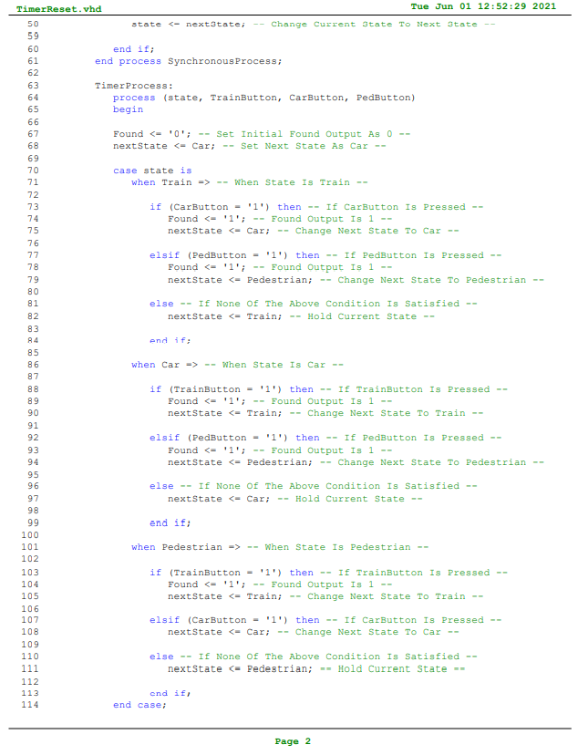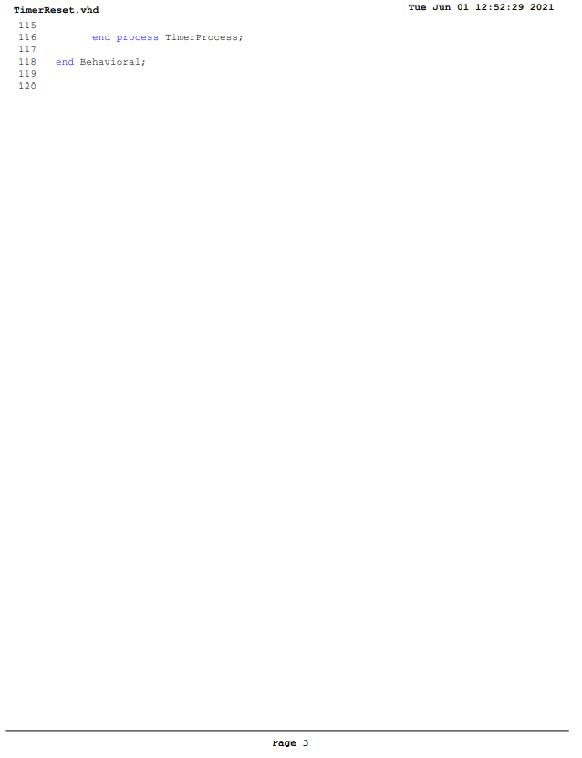

Figure 29: TimerReset Module Code

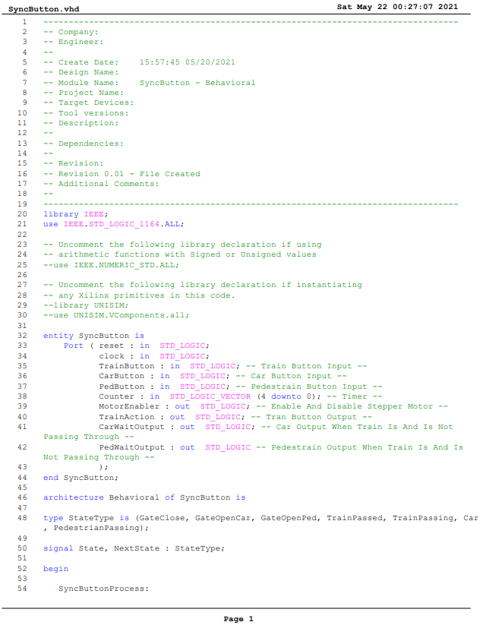



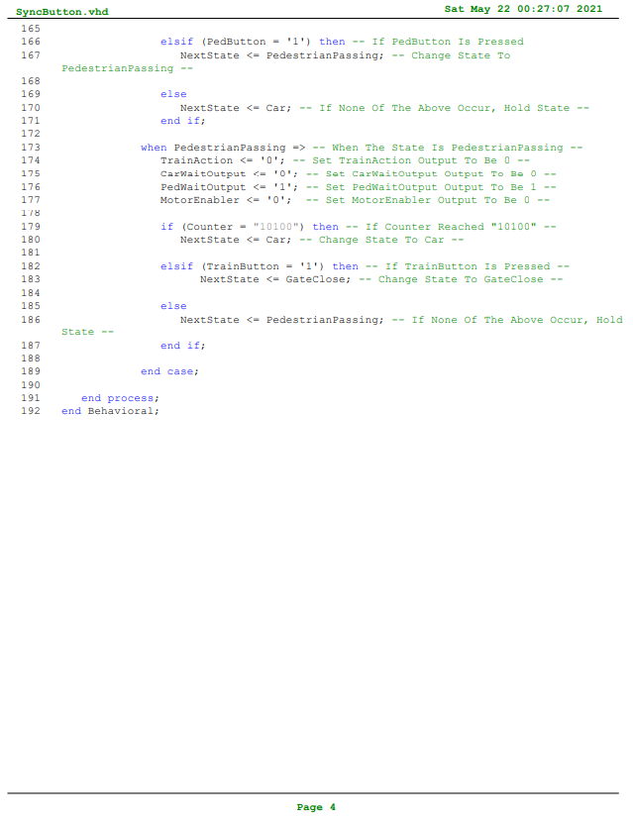

Figure 30: SyncButton Module Code

# ISE Synthesis Report

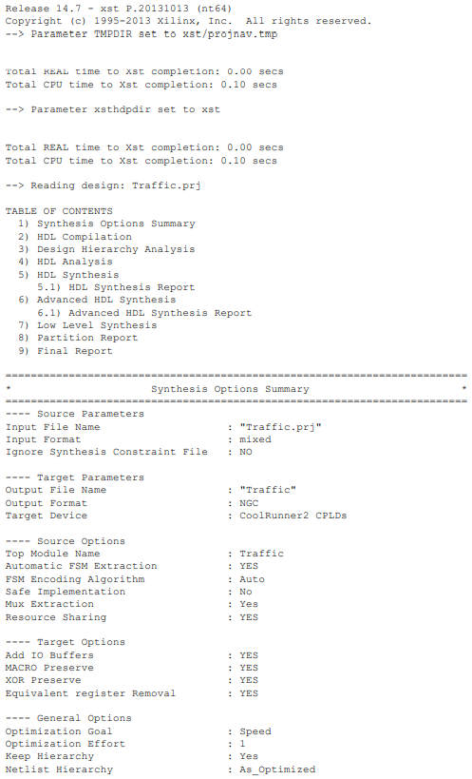

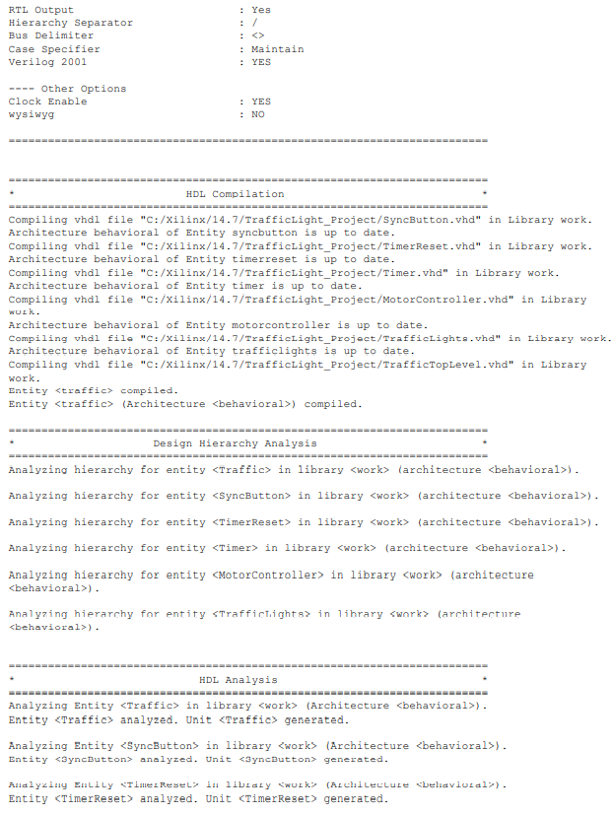

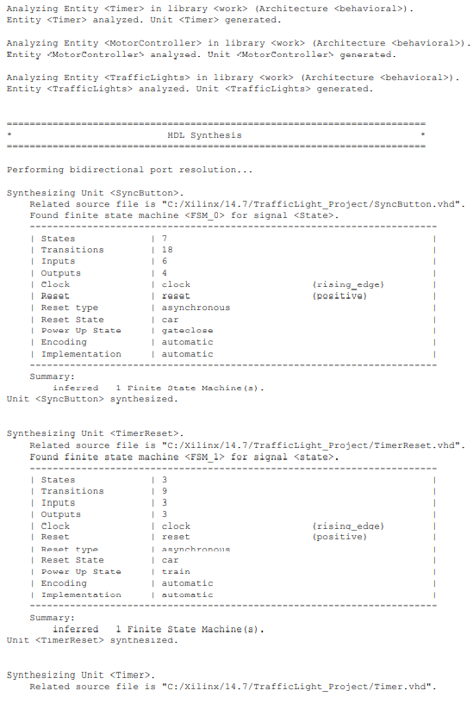

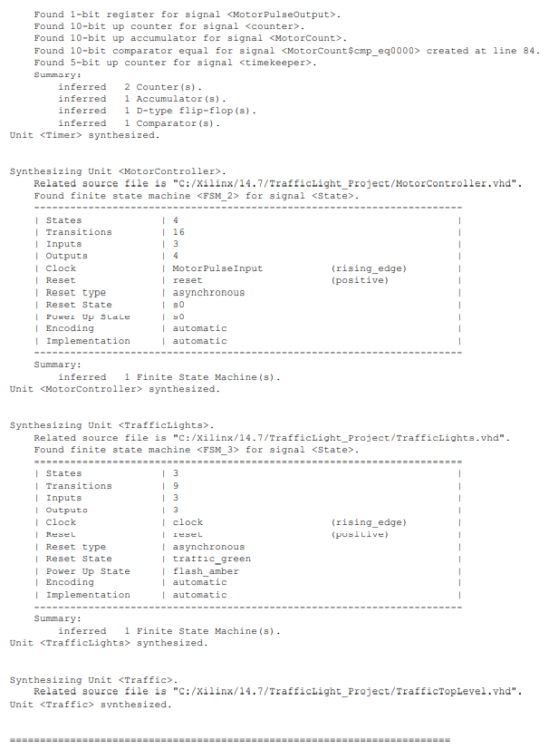

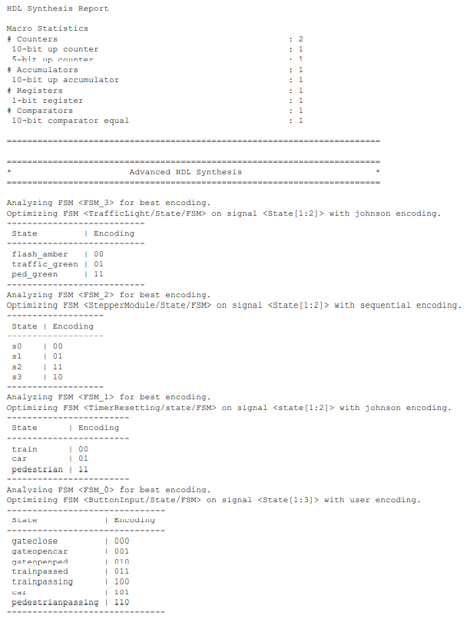

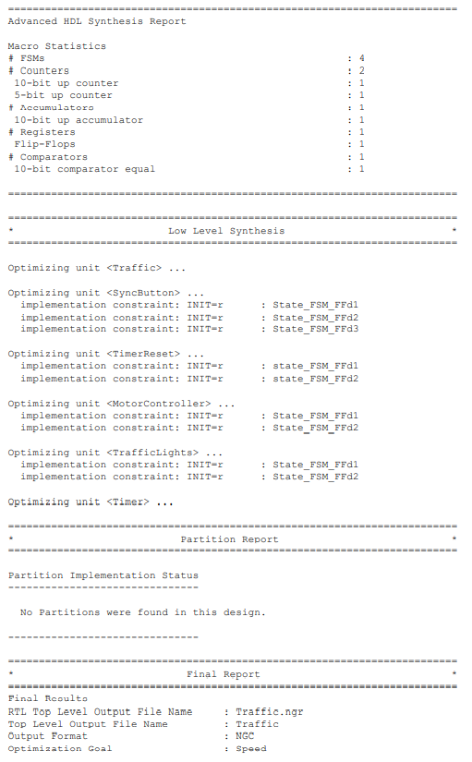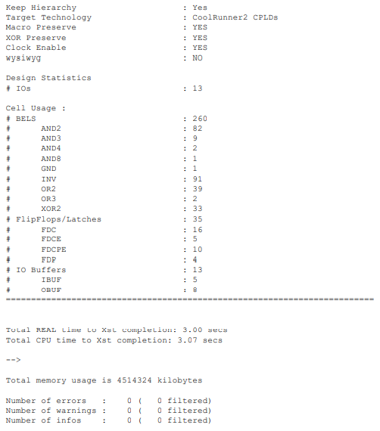

Figure 31: ISE Sysnthesis Report

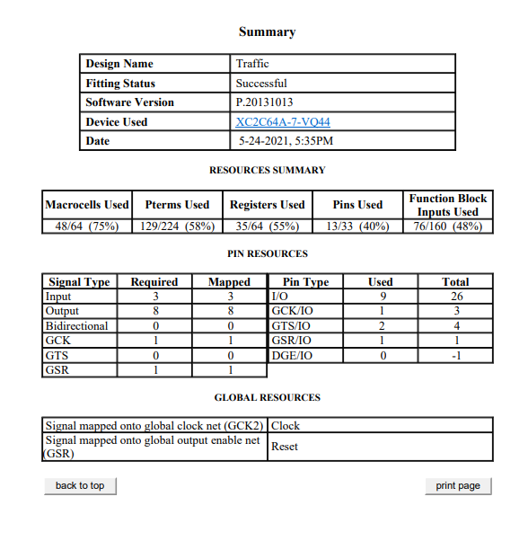

Figure 32: ISE Summary Report

# Appendix

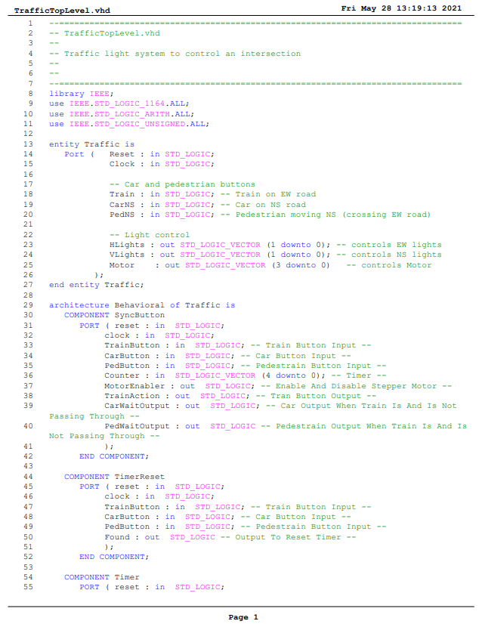

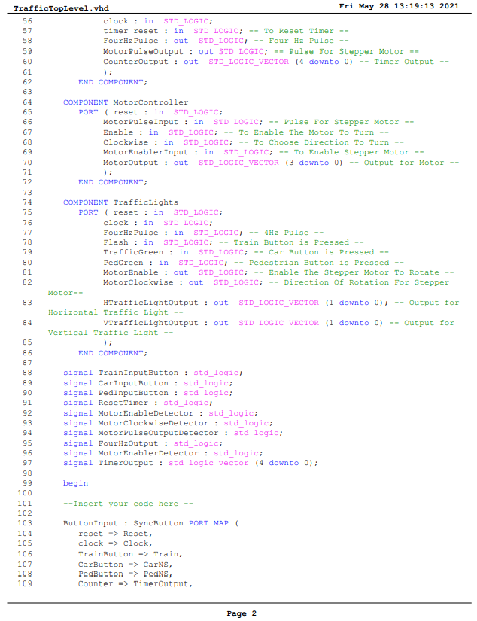

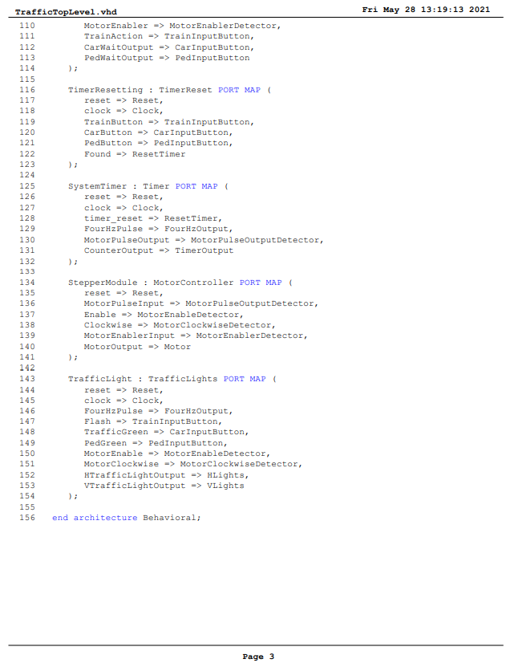

Figure 33: TrafficTopLevel.vhd Code

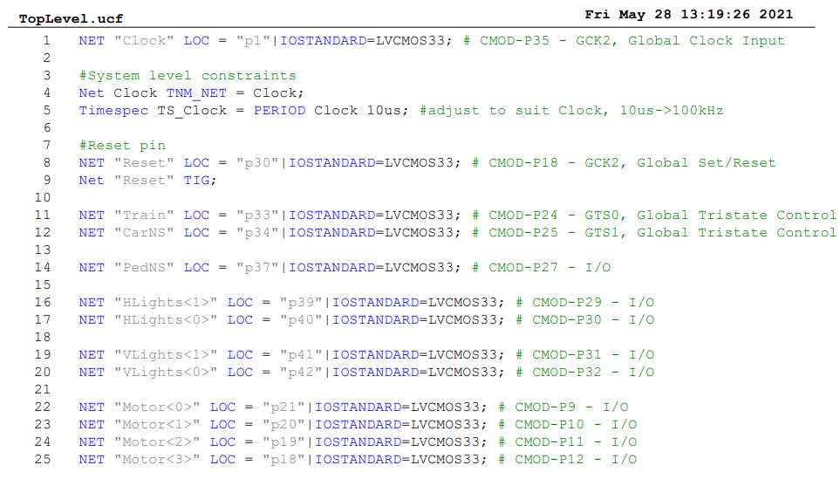

Figure 34: TopLevel.ucf Code